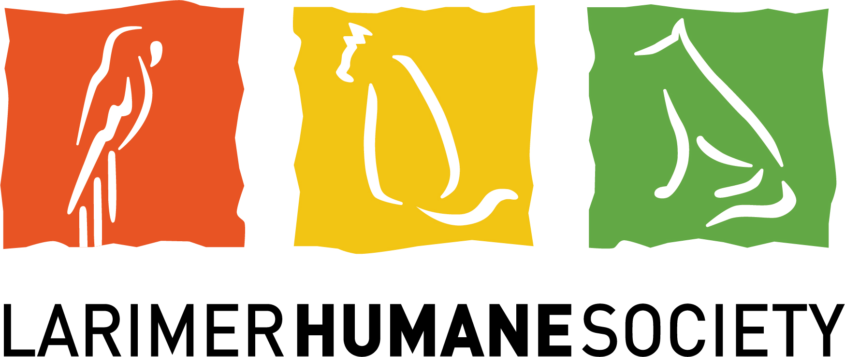
MEDIA CONTACT:
Kara Pappas │ Larimer Humane Society
O: 970.530.2960 l C: 970.227.0191
kpappas@larimerhumane.org
STATEMENT
October 8, 2021

Leadership Change at Larimer Humane Society

Larimer Humane Society’s Board of Directors announced the departure of CEO Nicholas Gilman, effective today. The board thanks Mr. Gilman for his work on behalf of Larimer Humane Society and wishes him the very best in his future endeavors.

The board will take time to formally assess the organization’s needs before it begins a leadership search, and will be appointing an Interim CEO shortly.

“Larimer Humane Society remains committed to building a community of people who are leading the way in providing trusted, responsive services that heal, nurture and protect,” said Board Chair Keith Meyer. “We are grateful to the Organization’s talented and dedicated staff and volunteer team, and have confidence in their steadfast service to the animals during this transition,” Meyer continued.

About Larimer Humane Society: Larimer Humane Society is an independent, non-profit animal welfare organization whose mission is to further the compassionate, safe, and responsible relationship between animals and people. As the largest open admission shelter in Northern Colorado, Larimer Humane Society is proud to accept all animals in need regardless of age, breed, medical status or temperament.

# # #

